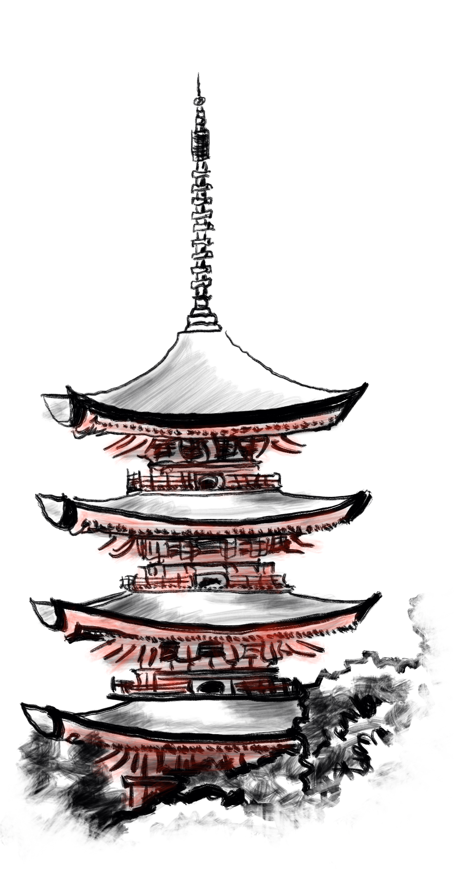
Outside
The Pagoda of Pazuzu
https://alexschroeder.ch/wiki/2018-04-28_The_Castle_of_Pazuzu
by Alex Schroeder

Creative Commons Attribution Share Alike 3.0 Unported
https://creativecommons.org/licenses/by-sa/3.0/

50 pilgrims (HD1 AC9 1d6) armed with sticks and stones are camping here. Eron the rabble rouser has led half of them here. He is well respected.

Entrance
2 wooden golems (HD4 AC3 1d8) armed with pole arms called Beginning and End guard the entrance. Touch both their feet and wish to see the tomb of Princess Anne.

Hall of Harmony
A giant statue of the four winged demon lord of foul winds and miscarriages, Pazuzu. 10 monks (HD1 AC8 1d6) guarding the hall. Stairs up.

Hall of Discipline
7 librarians (HD 4 AC7 1d6/1d6) oversee the library. They are called Elder Fist, Punch Hard, Hand of Discipline, Sign of Obedience, Iron Heart, Bronze Head, and Jumping Man. The walls and tables full of scrolls (about 2000 scrolls worth 50gp each). Each librarian wants a scroll reputedly owned by people in the area: Psalm of the Fourth Silence (Eron), Protection from Lycanthropes (a band of 7 ogres), Map to the Tomb of Ming the Fox (Knight Abulfred, killed by the Chimera Fuurdon at the Moon Pool of Aard), Scroll of Flying (Aeromancer Firdnad of the Southern Air Temple), Mercy of Baal (Green Pagoda of the Yak Master Esem), and so on. Spells to be learned from the librarians and their scrolls: charm person, jumping, air running, multiple fists, wind gust, gaseous form, shatter.

Sanctum of Tranquility
A long and winding passage guarded by 1000 little bronze statues. You must bend your head and murmur their name or take 1hp damage as you pass them. Clearly, a deadly proposition unless you know their names or have a guide.

Aerie of the Avatar
The vulture demon (HD7+1 AC2 2d6/2d6) and 2 tengu (HD4+1 AC5 1d8+3) guardians live up here. The demon is called Voice of the Inner Ear, the bird faced sword masters have no name but their swords do: Back Breaker +1/+3 vs. vertebrates and Child Killer +1/+3 vs. children.

